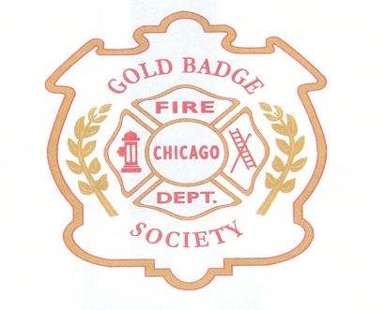

Due to a generous donation in memory of Eileen Coglianese by the Chicago Fire Department Foundation, the CFD Gold Badge Society is able to offer this special award for the Third year.

Winners will be notified (phone or email) by June 21st, 2024.

Please read carefully, incomplete, or late applications will be disregarded.
A lottery will determine the winner from qualifying applications. All judgments are final.

(2) $2500 Academic Scholarships will be awarded.

Eligibility Criteria:
- Dependent (Son or Daughter) of a Line of Duty Death member of the Chicago Fire Department
- Currently enrolled in school - First grade – College
- Completed Application
- Report Card or Transcript from the last Quarter or Semester of 2023 or First Quarter 2024

Application must be RECEIVED no later than May 31, 2024

SEE PAGE 2

Mail to:
CFD Gold Badge Society
c/o Beth Hurter Kelly
6030 W Patterson Ave
Chicago, Illinois 60634

OR

Email:
Bethhurter@gmail.com
DOCUMENTS MUST BE IN PDF OR WORD FORMAT

INCLUDE ALL NECESSARY DOCUMENTS WITH APPLICATION.
INCOMPLETE, INCORRECT, INELIGIBLE OR LATE APPLICATIONS WILL BE DISREGARDED.

Address questions to admin@cfdgoldbadgesociety.org Attn. Scholarship Committee

PLEASE PRINT CLEARLY
Student Name:
Female | Male
LODD Parent’s name:

Address
City, State, Zip code
Phone
Email address
School Name

